The Rt Hon Greg Clark MP

Department for Business, Innovation and Skills

1 Victoria Street, London, SW1H 0ET

[mpst.clark@bis.gsi.gov.uk](mailto:mpst.clark@bis.gsi.gov.uk)

Lord Ahmad of Wimbledon

Department for Communities and Local Government (DCLG)

2 Marsham Street, London, SW1P 4DF

[pslord.ahmad@communities.gsi.gov.uk](mailto:pslord.ahmad@communities.gsi.gov.uk)

11 November 2014

Dear Sirs,

**European funding for the visitor economy**

Councils have long recognised, and supported, the visitor economy’s value to local growth and prosperity, and its potential to generate local jobs. To date, European funding has played an essential role in supporting this activity, and I am writing to emphasise the need for this to continue.

I therefore welcome your commitment to devolve spending decisions for England’s £5.3 billion European Structural and Investment Funds (ESIF) for 2014-2020 to the 39 Local Enterprise Partnership (LEP) areas. It is critical this is used wisely, and delivers what is needed on the ground.

To make that happen, councils have done a tremendous amount of work with LEPs to put in place local ESIF strategies outlining their spending plans, source match funding and establish local arrangements. What is clear is that local partners need maximum autonomy over the way in which the funds are spent, and certainty that funds will flow as soon as possible from January 2015.

The LGA continues to play a pivotal role through the shadow Programme Growth Board to help you put in place arrangements to make this to happen. I understand arrangements have yet to be finalised, particularly on the Operational Programmes, which will determine what can be funded and the role local partners will have in determining spend.

I would like to reinforce LGA’s view that local plans, priorities and decision making arrangements must not change as a result of your ongoing negotiations with the EC, and highlight that the visitor economy continues to be boosted by EU investment. I have pleasure in sharing a copy of the recent LGA submission to the Culture, Media and Sport Committee’s Inquiry into the visitor economy, which sets out LGA’s analysis on the value of tourism to growth.

Yours sincerely

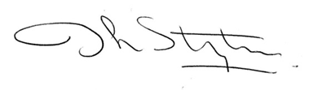

Cllr Ian Stephens

Chair, LGA Culture Tourism and Sport Board, and Leader, Isle of Wight Council

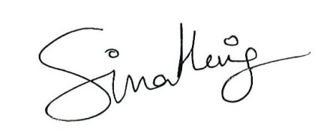

Cllr Simon Henig,

Deputy Chair, LGA Culture Tourism and Sport Board

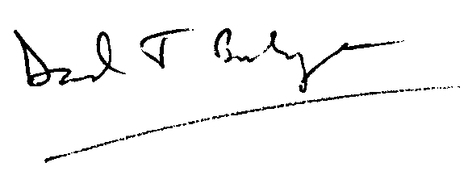

Cllr David Burbage,

Deputy Chair, LGA Culture Tourism and Sport Board



Cllr Flick Rea,

Deputy Chair, LGA Culture Tourism and Sport Board

cc

Helen Grant MP, Tourism Minister, Department for Culture, Media and Sport